For the Centennial Celebration of J. Moltmann in Seoul, South Korea

Friederike Moltmann
Seoul May 8, 2026

You all know my father as theologian, an immensely productive, creative, and visionary, theologian. For me he was of course a father as well. In addition, he was important for me as a role model and mentor for my own academic career, a role that he cared a lot about himself. I what follows I first want to talk about my father as a family man, of a family of four daughters, as a husband of another theologian, my mother Elisabeth Moltmann-Wendel, and as a role model for an international career. Second, I will talk about my father’s favorite thinker image the Korean pensive Bodhisattva, since that image itself in a way matches the nature of my father himself.

1. My father as a father

When growing up, we daughters always were aware that our father was very much focused on his work and was not easily available. His work went along with a strict discipline, in particular as a precise daily routine: Getting up shortly before 8am, breakfast at 8.15al, when we were already on our way to school. Then taking a walk in the nearby forest to gather his thoughts for a day’s work of writing - four pages in the morning and four pages in the afternoon during my father’s heyday. Then lunch at exact 12.30, usually prepared by my mother, but later also once a week by my father, to unburden my mother when she had resumed her career own again. After lunch, a ‘sacred’ siesta till 15.00. Subsequently, my father was at his desk again till 18.30. In the evening he usually made some time to be with his family, to watch some television together or to just talk, before retreating again around 9.30pm to gather his thought for the work of the next day or for future projects. This was often accompanied by classical music - Beethoven was his favorite, but also jazz, later he preferred Mozart. He kept such a discipline throughout his life, until his last days. It was certainly one of the foundations for producing such an immense work.
Unlike other prominent academics, he made a point of letting us in in his work. We often discussed theological or other intellectual issues, and he took us along to talks or sermons in churches. He thus let us take part in the deep joy he gained from his work as well as the pride in his international recognition and international invitations. He loved to take one or the other daughter along to a professional trip. For example, I remember well a trip when I was around thirteen. My father took me along to a theology conference to Prague and we visited the shadow theater Laterna Magica in the evening. He also made time for local excursions, to our vacation home in the Swabian alps, to nearby forests or spas, or to important monasteries, churches or other sights (my Prussian mother liked palaces, my father preferred churches). Visits of places of culture sometimes involved the whole family. I remember well a family trip to Dresden, where we visited both museums and the Semper Opera together, as well as the Meissen porcelain manufacture and a beautiful shop with wooden nutcrackers and other figures from Germany’s Erzgebirge. Such excursions continued until his last years.
Particularly noteworthy were his travels to visit me in Venice during the pandemic. I had moved from New York to Venice shortly after the pandemic started, knowing that it would be a historically unique occasion to experience Venice without the tourists that usually overwhelm most of the city. Well into his nineties, my father was thus able to visit me there three times, twice together with my sister Esther. These were deeply moving and joyful experiences for the three of us.
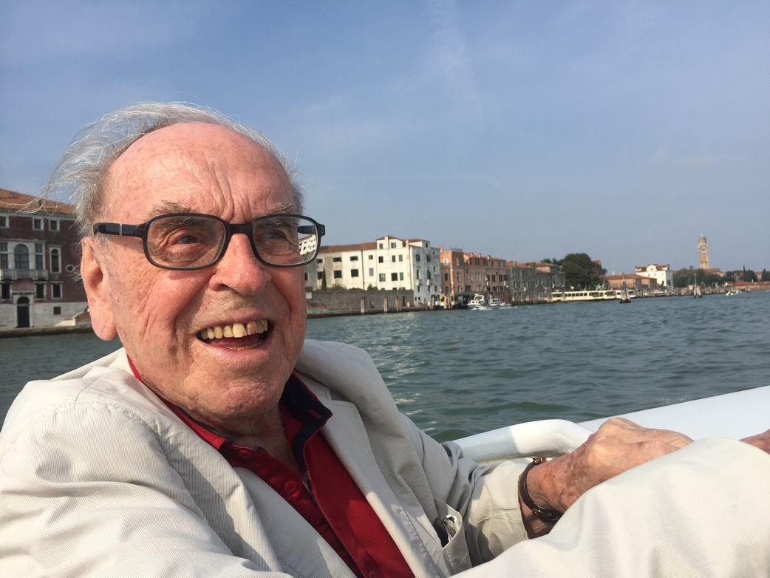
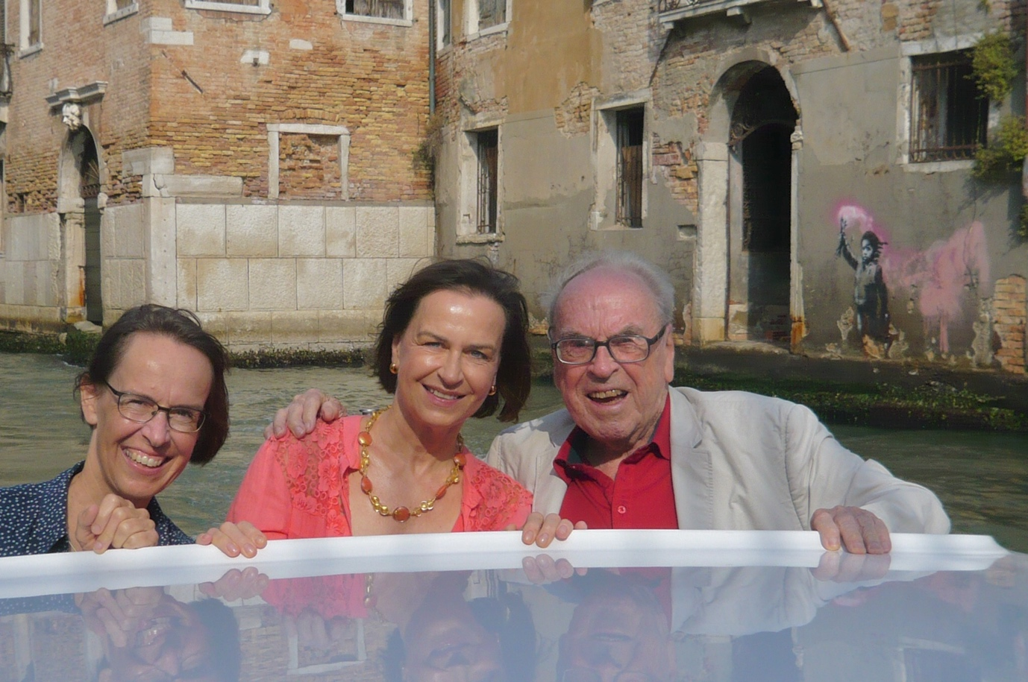

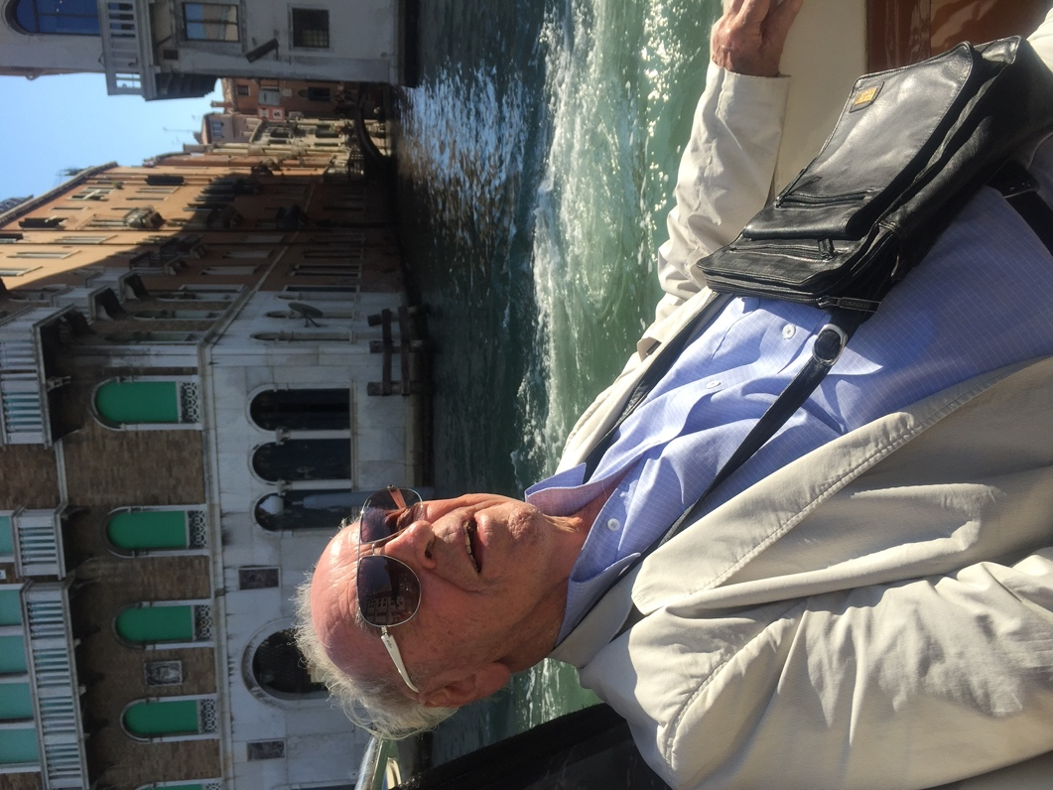

During that time, my father had started a new friendship with the patriarch of Venice Francesco Moraglia, whom we visited several times either in the sacristy of San Marco after a mass or in the patriarchal residence next to the basilica San Marco.
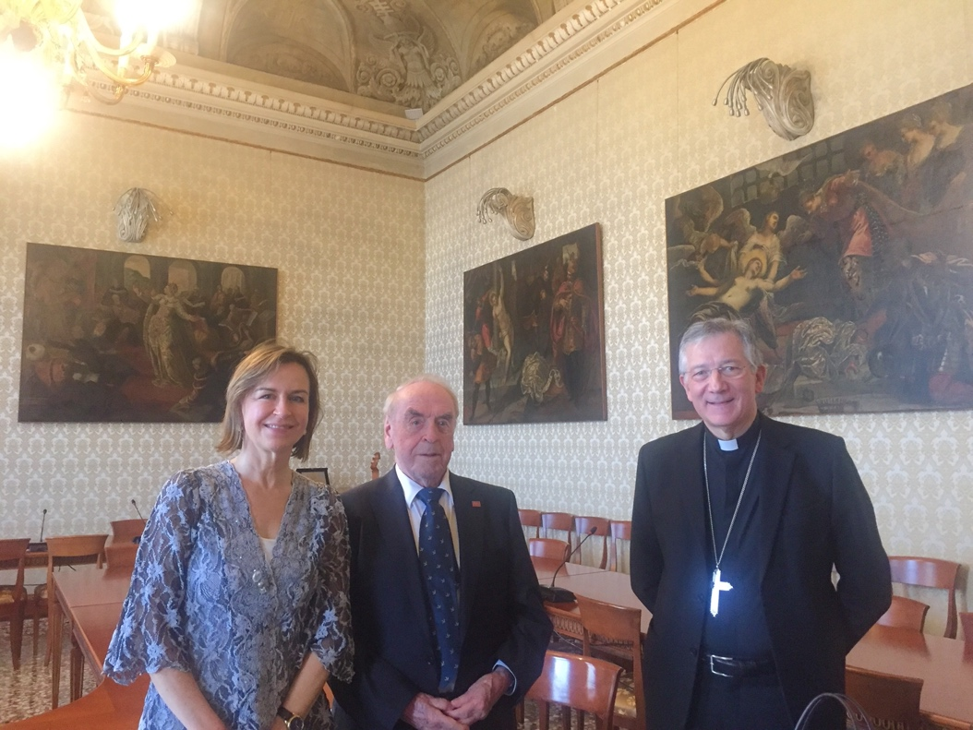

The patriarch of Venice organized a private guided tour of San Marco for us with special access to the golden altarpiece of San Marco, which had captivated my father:
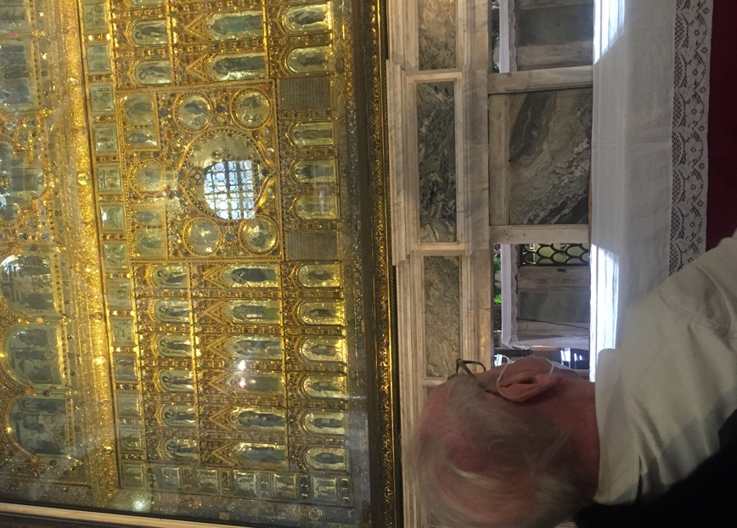
The Patriarch also honored my father by elaborating on his theology of hope during the mass in San Marco for the celebration of the 1600 year anniversary of the founding of Venice in 2021, a mass of which we were honorary guests.
We also were able to undertake ‘VIP tours’ of the spiritual islands of San Francesco del Deserto and San Lazzaro degli Armeni in the Venetian Lagoon, again enjoying special guided tours.
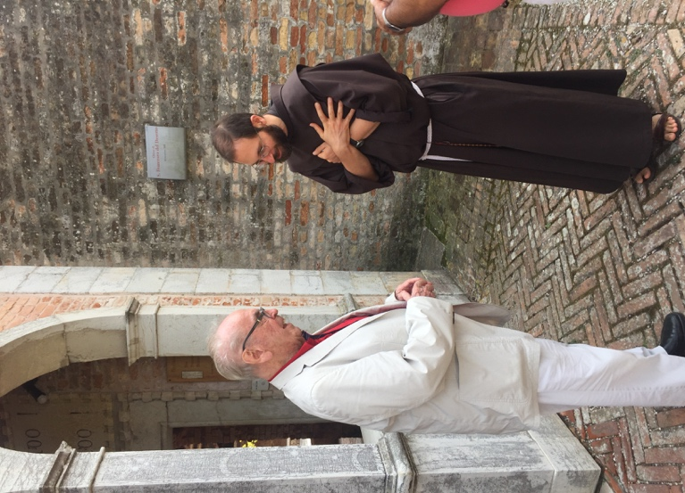

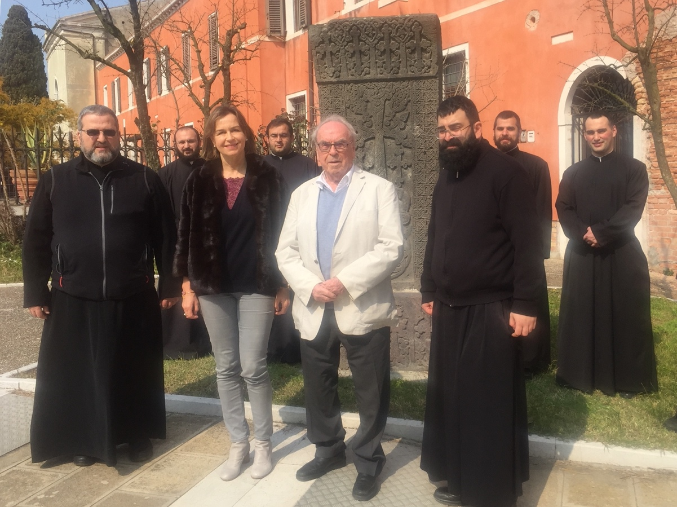
During ‘Zona Rossa’, the period when almost everything was closed in Italy, my father stayed in the only hotel open at the time, the magnificent Danieli hotel, a five-star hotel, which immediately upgraded my father’s room to a penthouse suite when they learned who he was. Each evening during that stay, I had dinner with my father on the roof top terrasse, almost the only people in the restaurant at the time. Each time after dinner, father asked to stay on at the table by himself for another half hour, contemplating the beautiful view of Venice, especially Santa Maria della Salute.
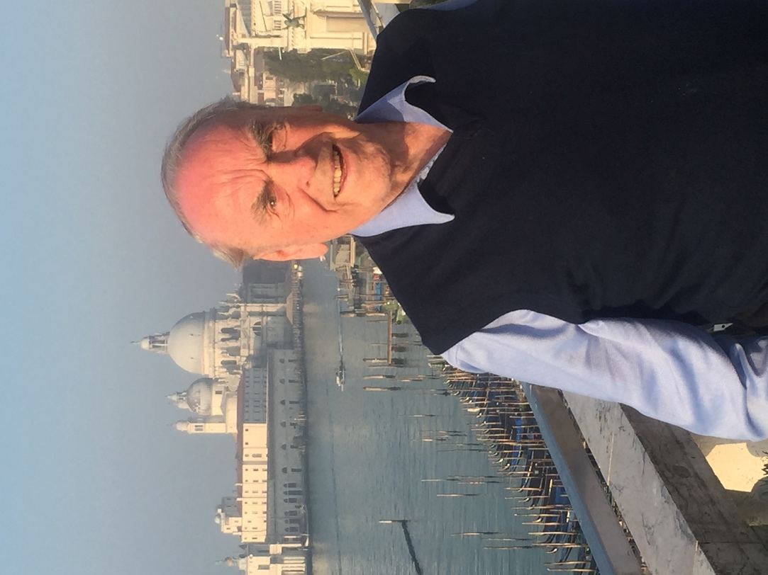

During those visits in Venice, my father also cared deeply about the bond that was strengthening between me and my sister. The visits of Venice are great example of the renewal of life and personal development that my father sought after my mother’s death.
My father’s love toward my mother had been profound: theirs was a highly symbiotic relationship, and they each regarded the other as ‘the great fortune of my life’. My mother’s death, even though it she had been very ill for some years, had devastated my father. Yet he found the strength to renew his life, with new ideas and publications, new travels, new friendships, and a deeper cultivation of family relationships. What had attracted my father most to my mother, on my view, was her deep joy of life and the encouragement and support she gave him. After my mother’s death, I had an artist friend from New York make a portrait of my mother on the basis of an early photograph, which I found represented those two qualities best:
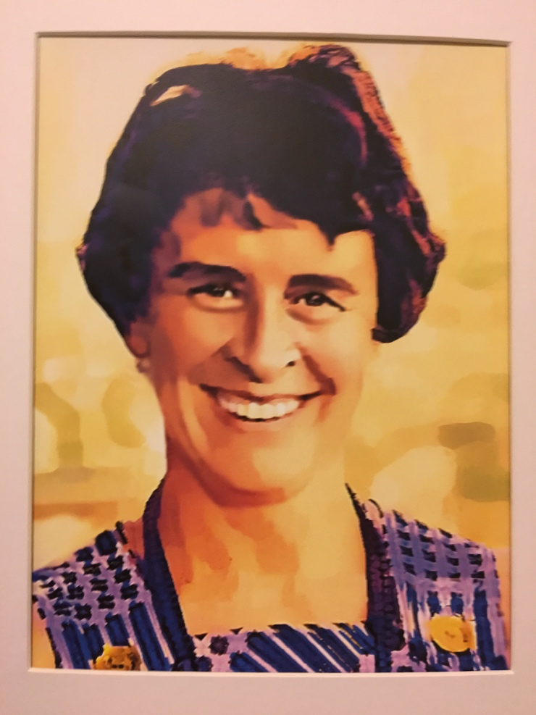

My father was in tears of joy when he received it.
Besides the trips and excursions, my father always made time when one of us daughters had a serious problem or was in serious need. He then was very generous with his attention and care as well as with follow-ups. Another remarkable quality of my father as a family man was is sense of equality: he made sure to treat all of his daughters equal, whether with his time and attention or materially.
My father had a special importance to me, as his only daughter that had pursued an international academic career. My own academic career is in a rather field, the interface between linguistics and philosophy, which is driven by a strict empirical and formal methodology. My father was initially reserved when after the first year of my studies, I chose analytic philosophy and theoretical linguistics rather than historical and continental philosophy as he had expected. But soon after he embraced my passion for such a formal and analytic field, with a methodology so different from his own, and he became a pillar of continuous support of my career throughout my studies and professional life. He even sometimes contributed good linguistic examples from the theological realm when I told him about a topic I was working on. I can call myself immensely blessed to have had such a great role model for an academic career.

2. My father’s favorite thinker image

My father’s study was filled with books, including of course his own books and their numerous translations. But it also contained a great number objects of art, such as icons, woodblock prints, sculptures, and lacquer boxes. My father thought in images, and certainly the selection of art objects surrounding him in his study were sources of inspiration.
The most distinguished place for such objects of inspirations was the window board above his desk. The large window of his study had a stunning, sprawling view of the outskirts of Tuebingen and the adjacent countryside, with the Swabian alps being well visible in the distance. One of the figures on that board was a bronze reproduction of the Korean pensive bodhisattva. In this photo of my father of early 2024 we can see the small Bodhisattva statue at the window:

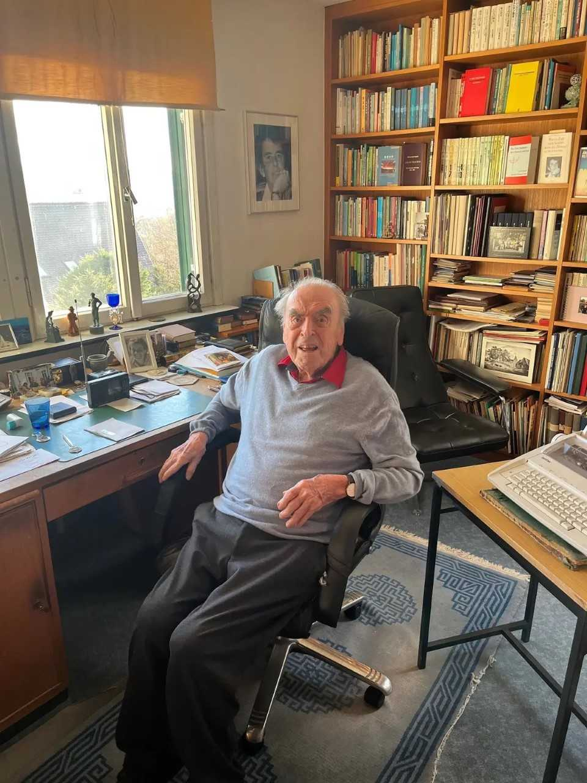

Here is a close-up of the Korean statue on that window board:

My father had two other small reproductions of the Korean pensive bodhisattva in our home. One of them stood on the window board of the ‘Asian room’, a reading room filled with Asian paintings sculptures and vases adjacent to his study. Another one stood in the living room surrounded by the blue-white porcelain collection that was the pride of my mother:
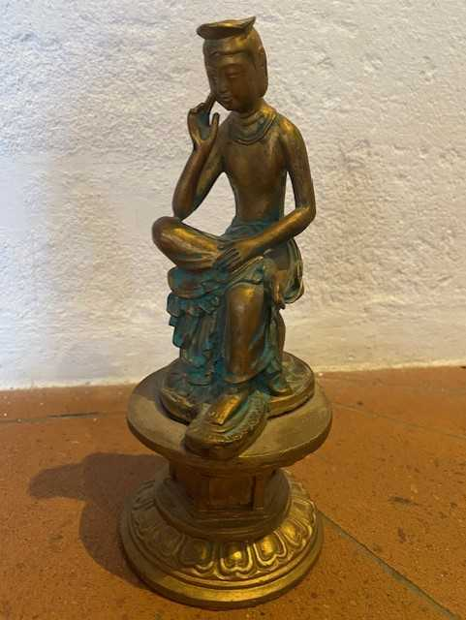
The Korean pensive Bodhisattva also figured in a framed photograph in the Asian room and on a postcard that my father had sent me from one of his first trips to South Korea.
Here we see two particularly important examples of the pensive Bodhisattva, the two national treasures in in the Korean National Museum in Seoul:

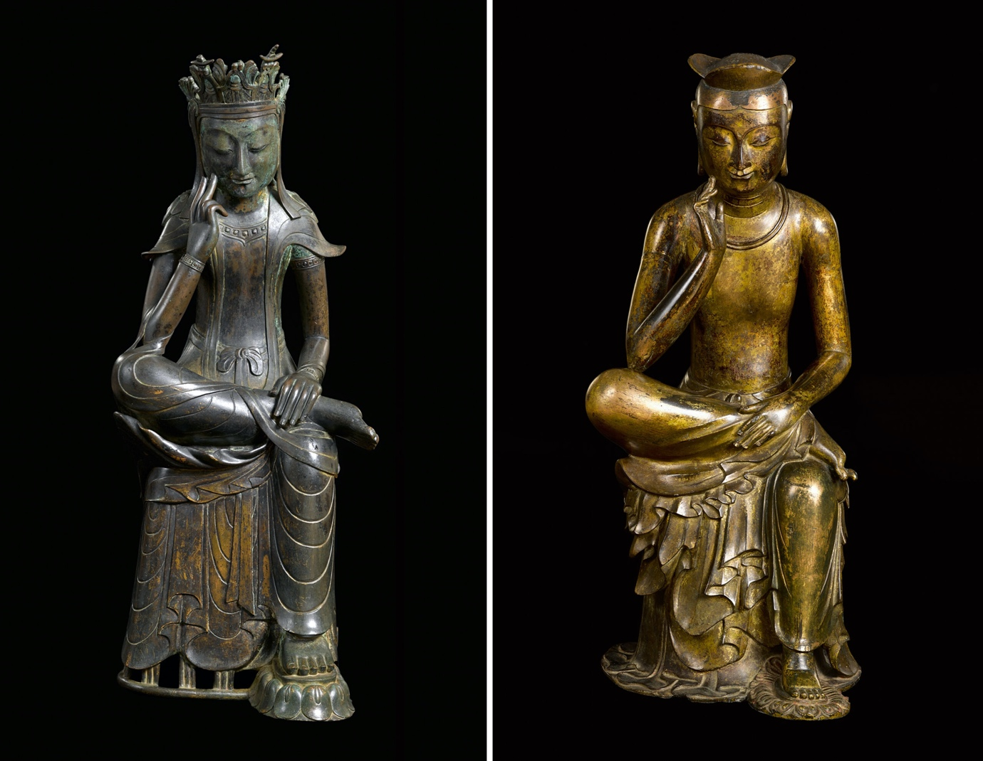

Besides the pensive Bodhisattva, the dancing Shiva of hinduism was a divine (non-Christian) image that that my father was particularly drawn to, that is, the dancing god that destroys and recreates the world, for my father a personification of creativity:

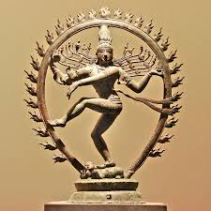

I was lucky to inherit my father’s wooden shiva statue, which always reminds me of my father’s creativity and inspires me for my own.
There are particular reasons why my father was so drawn to the pensive Bodhisattva. First, it has to do with what the Bodhisattva represents to the theologian of hope: it is the representation of Maitreya, the Buddha of the future, that is the Buddha that reappears on earth in some distant future. It is also the Buddha that helps humans obtain enlightenment, serenity, and eternal joy. This of course not only resonates with the theologian of hope, but also constitutes a link between Buddhism and Christianity. Hope is fundamental to Christian faith, on my father’s view, that is, hope is for the real world, not for a realm of heaven beyond it
However, it is also the bodily position of the bodhisattva my father was so attracted to. This can be appreciated when we contrast the Korean thinker with the most well-known thinker statue in the Western world, the thinker of Auguste Rodin:

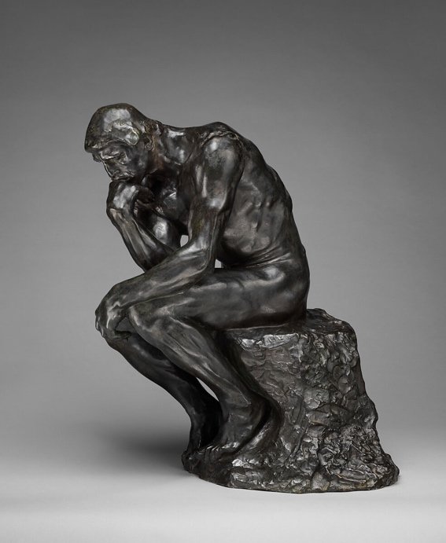

Rodon’s thinker represents a rather tortured and very male, muscular thinker. The act of thinking here is represented as a difficult, almost painful act, which imposes stress on mind and body. This contrasts strikingly with the pose of the pensive Korean Bodhisattva, which is serene, almost relaxed. This holds both for the overall sitting pose and the way the hand gives only light support of the chin. The Korean bodhisattva shows grace and lightness and a smiling face, even when being aware of death of suffering, and its appearance seems neither masculine nor feminine.
My father was so attracted to the Korean thinker that he subconsciously liked to adopt the very same thinker pose himself. This is particularly striking in one of his best-known portraits:

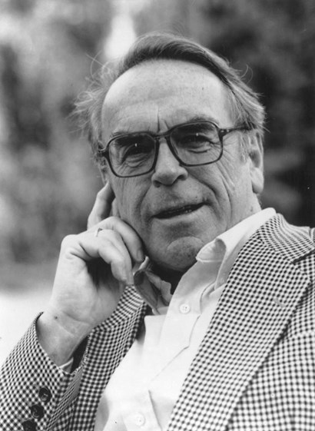

This portrait shows my father’s own characteristic thinker pose, which is that that of the Korean pensive Bodhisattva, not that of Rodin’s thinker. The Korean Bodhisattvas shows serenity and lightness even in face of suffering, features that are characteristic of my father himself when at his best.

I never had a general conversation about thinker statues with my parents. However, the thinker image recurs in other places in our family. Thus, when I was to choose a cover for my recent book Objects and Attitudes (Oxford UP, 2024), I decided on a photograph of the Korean national treasure in the National Museum of Seoul, in part recalling my father’s love for the Korean thinker:

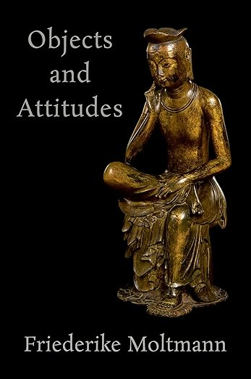

My father was still able to see the cover of the book, but unfortunately not the book itself when it came out at the end of 2024.

In addition, one of the favorite photographs my father had of my mother was one where she herself adopted the thinker pose, though not quite that of the Korean pensive Bodhisattva. The photo hung in my father’s study since her death:

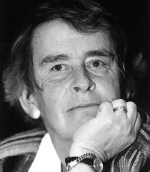

My mother herself had a favorite portrait of me in her study, namely my self-portrait at the age of 15 as a thinker:

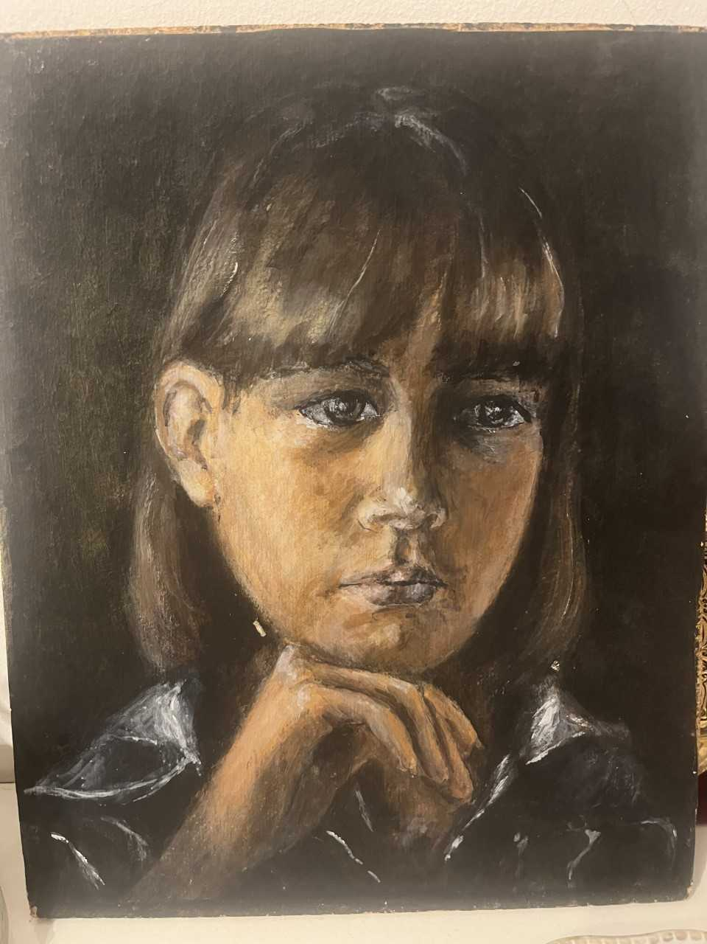

I would like to add a final remark about thinker images in general and the Christian tradition in particular. in general. From all I can tell, my father was not aware of a broader tradition of thinker images. But both my parents with their interest in the representation of concepts through images would have been keen to learn that there were fascinating traditions of representing thinkers across different cultures. My mother would have loved to see female thinkers being represented in various cultures or historical periods. My father would have been interested in the Christian tradition of the pensive anxious Christ, so different from the Korean thinker. Here is an example of that tradition, a woodblock print by Albrecht Duerer (1511):

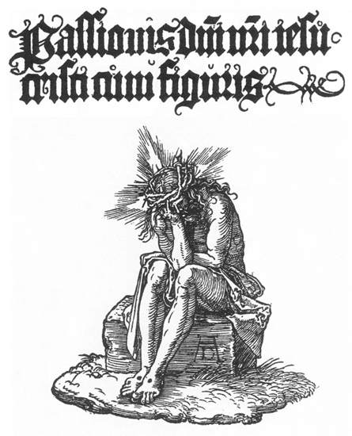
Though the pensive Christ in the Northern and Eastern tradition displays suffering without serenity, lightness, or hope, my father would have been thrilled to learn about a contemporary monumental sculpture (2009) in the Italian Dolomites:

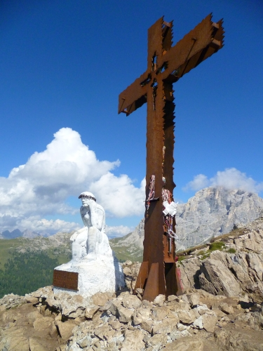

That sculpture situates itself in that same Christian tradition, but represent not only suffering, but also hope. Its inscription encourages the viewer to not only think and pray, but also to smile, in English translation:

‘Take the time to think, Take the time to pray, Take the time to smile’.

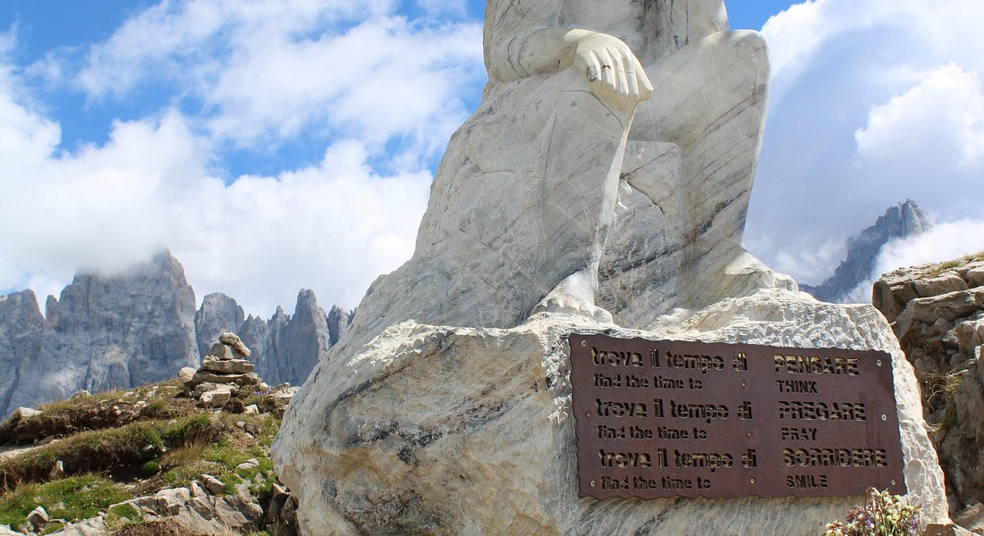

This inscription recalls my father’s own famous saying:

‘God weeps with us so that we may someday laugh with him.’

